Hallbrook Primary School


Believe. Achieve. Succeed.

A step by step guide for parents on
the new calculation policy.
February 2019

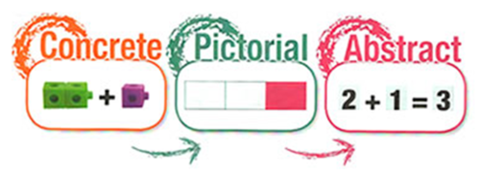

What does ‘Mastery’ mean in Mathematics?

Inspired by teaching approaches developed in Singapore and Shanghai, mastering maths means acquiring a deep, long-term, secure and adaptable understanding of the subject - which every child can achieve. A concept is deemed mastered when learners can represent it in multiple ways, can communicate solutions using mathematical language and can independently apply the concept to new problems. It demonstrates how skilfully a child can apply their learning.
Mastery is not just knowing a fact, but it is using that fact in increasingly more complex situations.

What does ‘Mastery’ in maths look like at Hallbrook?
At Hallbrook Primary School, we are determined to ensure that your child receives the highest quality of education possible. We strive to achieve this through teaching well planned lessons that allow children to ‘Master’ the maths curriculum through being: fluent in the fundamentals of mathematics; reason mathematically and solve problems by applying their mathematics to a variety of problems.

Within this booklet, there will be different methods and strategies that children can use to support their working out of addition, subtraction, multiplication and division problems. Starting children off with concrete materials is a good start for children to manipulate and see what they are working with. Pictorial methods follows this by drawing pictures to help a child to see the problem and to work out how to solve this. Once children understand the concept behind working out the answer, they can then move on to the abstract methods.

We would ask that when you are supporting your child with Mathematics at home that you use these methods. We understand they may not all be familiar to you and therefore if you need any further support or explanation please speak to your child’s teacher.

ADDITION
Concrete, pictorial and abstract are different ways to manipulate and represent the methods.
 | Concrete  (Physical manipulation) | Pictorial  (Visual representations) | Abstract  (mental methods)
Combining two parts to make a whole. | Use other resources too e.g. eggs, shells, teddy bears, cars.  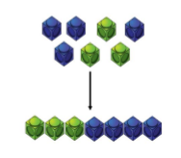 | Children to represent the cubes using dots or crosses. They could put each part on a part whole model too.  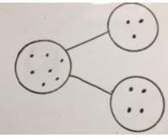 | 4 + 3 = 7  Four is a part, 3 is a part and the whole is seven.  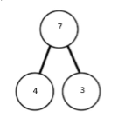
Counting on using number lines. | Using cubes or Numicon.  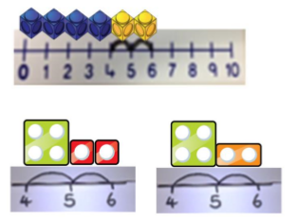 | A bar model which encourages the children to count on, rather than count all.  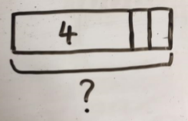 | The abstract number line: What is 2 more than 4? What is the sum of 2 and 4? What is the total of 4 and 2? 4 + 2  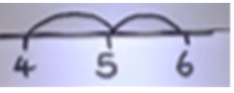
Regrouping to make 10. | Using ten frames and counters/cubes or using Numicon. 6 + 5.  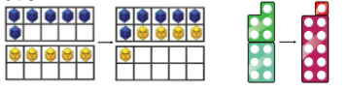 | Children to draw the ten frame and counters/cubes.  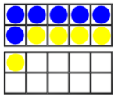 | Children to develop an understanding of equality e.g.  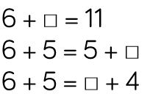
TO + O using base 10. | Continue to develop understanding of partitioning and place value. 41 + 8.  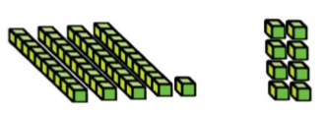 | Children to represent the base 10 e.g. lines for tens and dot/crosses for ones.  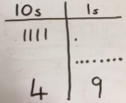 | 41 + 8  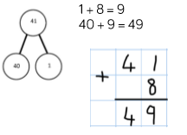
TO + TO using base 10 | Continue to develop understanding of partitioning and place value. 36 + 25.  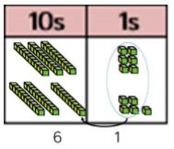 | Children to represent the base 10 in a place value chart.  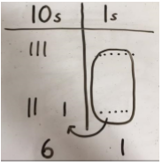 | Looking for ways to make 10.  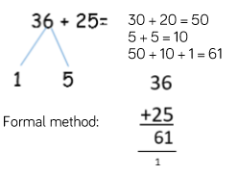
Use of place value counters to add HTO + TO, HTO + HTO etc | When there are 10 ones in the 1s column- we exchange for 1 ten, when there are 10 tens in the 10s column- we exchange for 1 hundred.  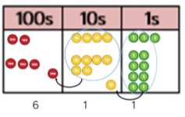 | Children to represent the counters in a place value chart, circling when they make an exchange.  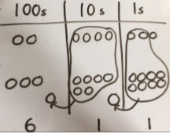 | Column methods carrying over the exchanges to the next column.  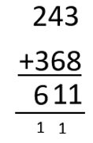

Subtraction
Concrete, pictorial and abstract are different ways to manipulate and represent the methods.
 | Concrete  (Physical manipulation) | Pictorial  (Visual representations) | Abstract  (mental methods)
Physically taking away and removing objects from a whole | Ten frames, Numicon, cubes and other items such as beanbags could be used.  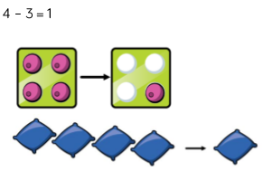 | Children to draw the concrete resources they are using and cross out the correct amount. The bar model can also be used.  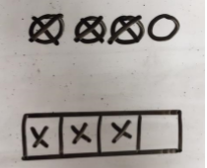 | 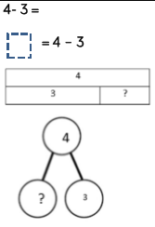
Counting back | Using number lines or number tracks) children start with 6 and count back 2.  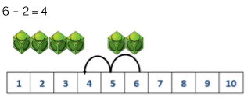 | Children to represent what they see pictorially e.g.  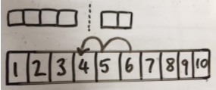 | Children to represent the calculation on a number line or number track and show their jumps. Encourage children to use an empty number line.  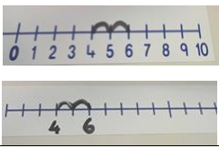
Finding the difference | Using cubes, Numicon or Cuisenaire rods, other objects can also be used.  Calculate the difference between 8 and 5.  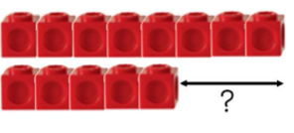 | Children to draw the cubes/other concrete objects which they have used or use the bar model to illustrate what they need to calculate.  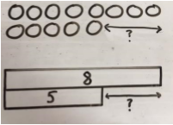 | Find the difference between 8 and 5.  8 – 5, the difference is  Children to explore why 9 - 6 = 8 – 5 = 7 – 4 have the same difference.
Making 10 | Using ten frames. 14 – 5.  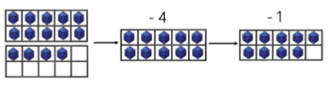 | Children to present the ten frame pictorially and discuss what they did to make 10.  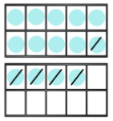 | Column method or children could count back 7.  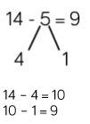
Column method | Using base 10.  48-7  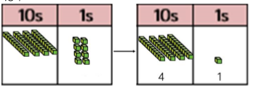 | Children to represent the base 10 pictorially.  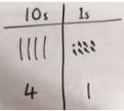 | Column method or children could count back 7.  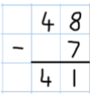
Column method | using base 10 and having to exchange. 41 – 26.  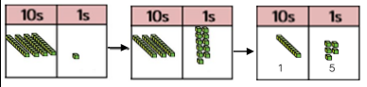 | Represent the base 10 pictorially, remembering to show the exchange.  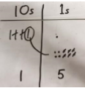 | Formal column method. Children must understand that when they have exchanged the 10 they still have 41 because 41 = 30 + 11.  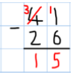
Column method | using place value counters.  234 – 88  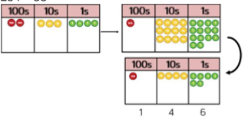 | Represent the place value counters pictorially; remembering to show what has been exchanged.  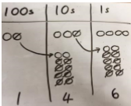 | Formal column method. Children must understand what has happened when they have crossed out digits.  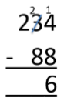

Multiplication
Concrete, pictorial and abstract are different ways to manipulate and represent the methods.
 | Concrete  (Physical manipulation) | Pictorial  (Visual representations) | Abstract  (mental methods)
Repeated grouping/  repeated addition | 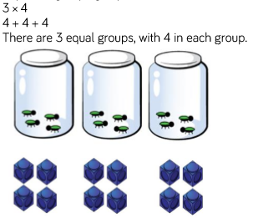 | 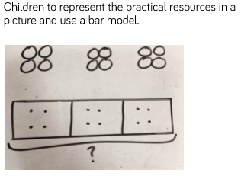 | 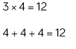
Number lines to show repeated groups- | 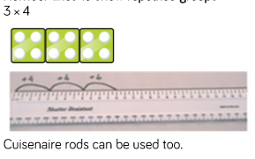 | Represent this pictorially alongside a number line e.g.:  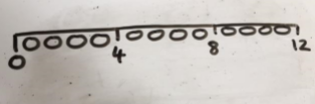 | Abstract number line showing three jumps of four.  3 × 4 = 12  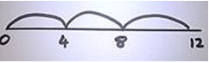
Use arrays to illustrate commutativity | Counters and other objects can also be used. 2 × 5 = 5 × 2  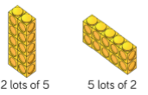 | Children to represent the arrays pictorially.  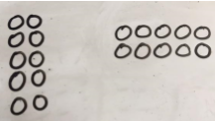 | Children to be able to use an array to write a range of calculations e.g.  10 = 2 × 5  5 × 2 = 10  2 + 2 + 2 + 2 + 2 = 10  10 = 5 + 5
Partition to multiple | Using Numicon, base 10 or Cuisenaire rods. 4 × 15.  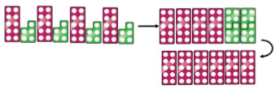 | Children to represent the concrete manipulatives pictorially.  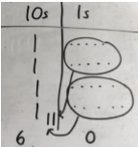 | Children to be encouraged to show the steps they have taken.  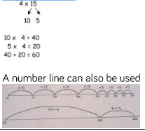
Formal column method | With place value counters (base 10 can also be used.) 3 × 23.  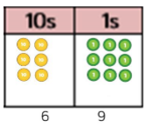 | Children to represent the counters pictorially.  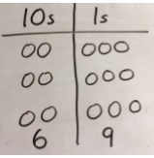 | Children to record what it is they are doing to show understanding.  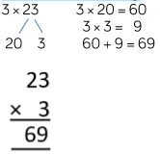
Formal column method | With place value counters. 6 x 23.  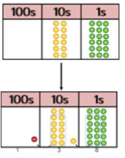 | Children to represent the counters/base 10, pictorially e.g. the image below.  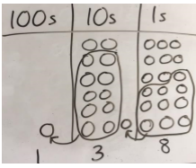 | Formal written method.  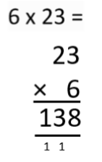
 | When children start to multiply 3d × 3d and 4d × 2d etc., they should be confident with the abstract:  To get 744 children have solved 6 × 124. To get 2480 they have solved 20 × 124. |  | 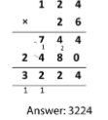

Division
Concrete, pictorial and abstract are different ways to manipulate and represent the methods.
 | Concrete  (Physical manipulation) | Pictorial  (Visual representations) | Abstract  (mental methods)
Sharing | Using a range of objects. 6 ÷ 2.  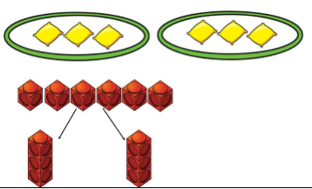 | Represent the sharing pictorially.  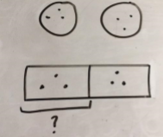 | 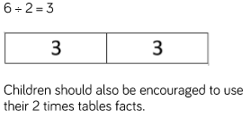
Repeated subtraction | Using Cuisenaire rods above a ruler. 6 ÷ 2.  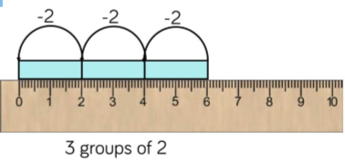 | Children to represent repeated subtraction pictorially.  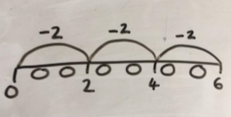 | Abstract number line to represent the equal groups that have been subtracted.  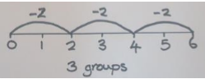
2d ÷ 1d with remainders | using lollipop sticks. Cuisenaire rods, above a ruler can also be used. 13 ÷ 4  Use of lollipop sticks to form wholes- squares are made because we are dividing by 4.  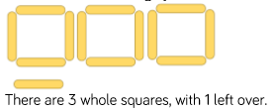 | Children to represent the lollipop sticks pictorially.  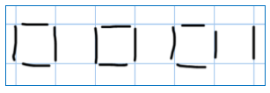  There are 3 whole squares, with 1 left over. | 13 ÷ 4 – 3 remainder 1  Children should be encouraged to use their times table facts; they could also represent repeated addition on a number line.  ‘3 groups of 4, with 1 left over’  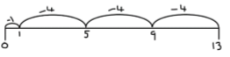
Sharing using place value counters. | 42 ÷ 3 = 14  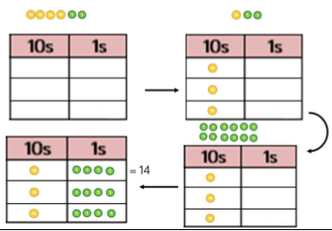 | Children to represent the place value counters pictorially.  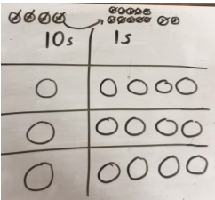 | Children to be able to make sense of the place value counters and write calculations to show the process.  42 ÷ 3  42 = 30 + 12  30 ÷ 3 = 10  12 ÷ 3 = 4  10 + 4 = 14
Short division | Using place value counters to group. 615 ÷ 5.  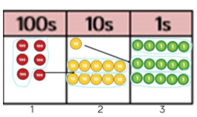  1. Make 615 with place value counters.  2. How many groups of 5 hundreds can you make with 6 hundred counters?  3. Exchange 1 hundred for 10 tens.  4. How many groups of 5 tens can you make with 11 ten counters?  5. Exchange 1 ten for 10 ones.  6. How many groups of 5 ones can you make with 15 ones? | Represent the place value counters pictorially.  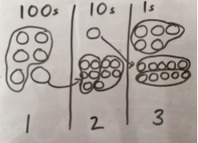 | Children to the calculation using the short division scaffold.  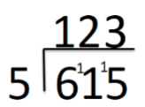
 | 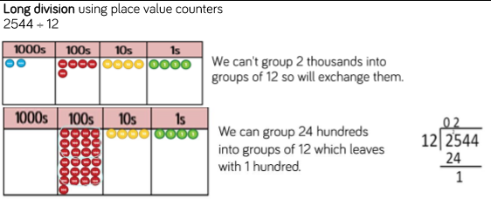

Representations from White Rose Maths.

