Reading Books for children whilst learning from home
For home reading whilst the children are learning at home, we would like you to register with Oxford Owl ebooks. This is a completely free ebook library and your child can access many texts at their own book band level whilst also be free to read and enjoy books from other book bands. There are also books available for older children who are no longer using the book bands for independent learning.
Below is a quick guide to registering and using the site:
- Go to: https://www.oxfordowl.co.uk/?selLanguage=en&mode=hub
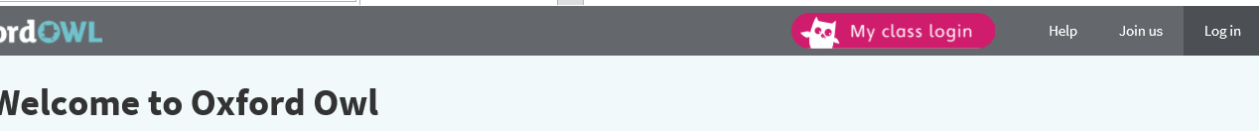
- Click on ‘Join us’ – this is in the top right hand corner - and register as a parent.
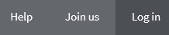
- Once registered, log in and choose the ‘ebooks’ option.
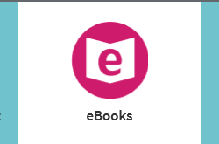


- Go to ‘Levels’ and use the drop down box to select the book band of your choice
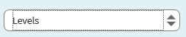
There are other options that allow your child to choose the type of books they enjoy, for example poetry, biography, classic, audio etc. They could also select a reading book by age group if they prefer. For our younger pupils, there are a number of phonics readers available.
- Once you have selected a reading book, click on it and the information about that book will appear in a window above the book.
- Click on ‘Read ebook> to enjoy your book!
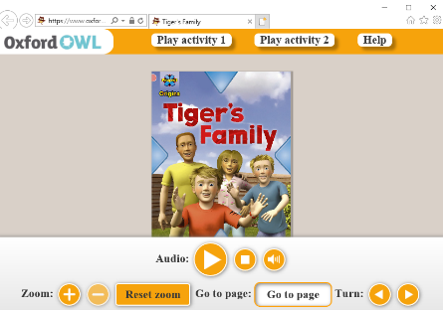

- Use the tools at the bottom of the page to
read the book.

There is also a free online library linked to your local library services. You need your local library card to sign up for this – go to Borrowbox.com to access this option.


