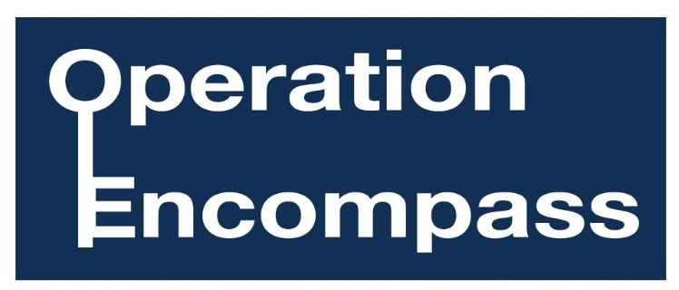
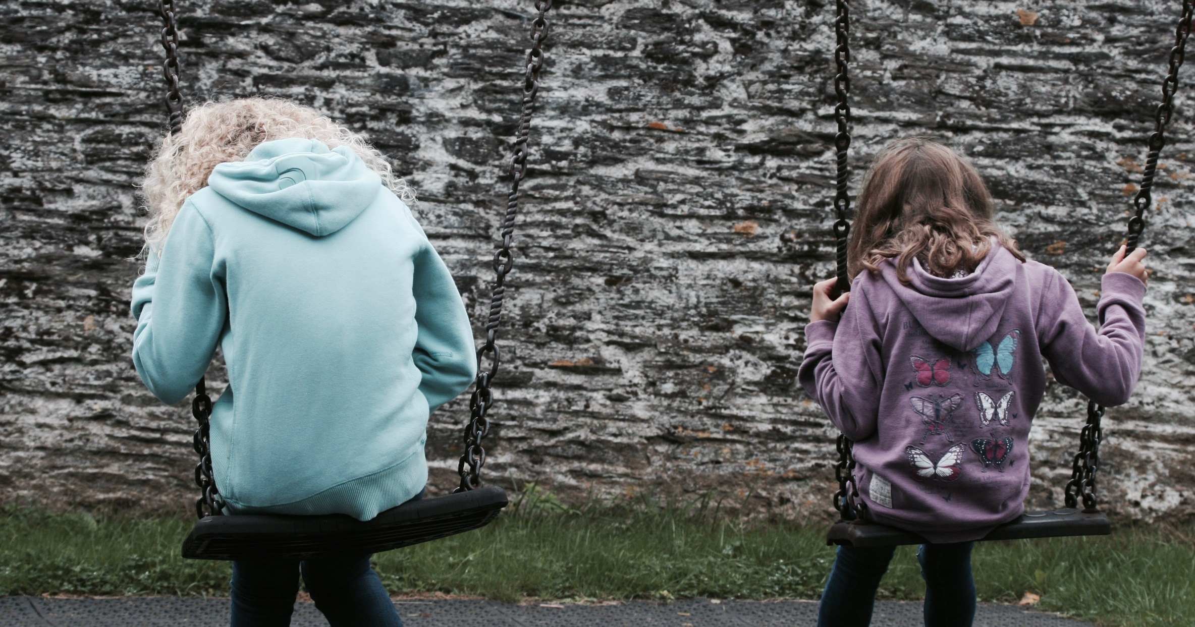
Photo posed by models
We are an Operation Encompass school. For further information, please come in and see us.
Supporting Children Exposed to Domestic Abuse

