PRE SCHOOL ADMISSIONS FORM

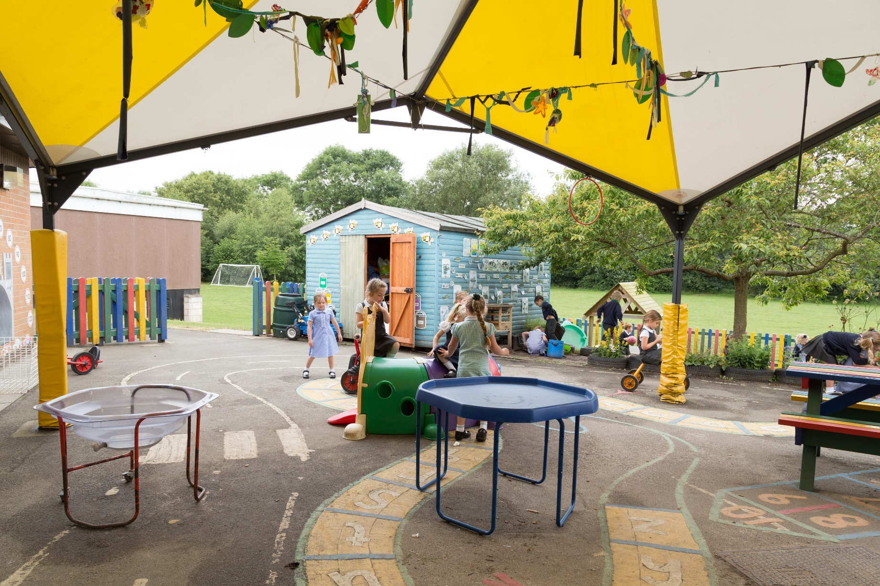

BELIEVE. ACHIEVE.SUCCEED.


WELCOME TO HALLBROOK PRIMARY SCHOOL
I am proud to be the Head Teacher of a school that celebrates every child’s talents and abilities. We have a highly dedicated school team that is committed to the safety and care of our pupils, developing each child’s knowledge, skills and understanding. We aim to provide the highest quality education for all in a caring, supportive, inclusive and vibrant learning environment.
At Hallbrook, you will find that we offer an exciting curriculum where teachers and pupils work together to ensure high quality teaching and learning opportunities that enable all pupils to flourish and achieve the very best. We recognise that every child deserves to fulfil their potential as successful learners, confident individuals and responsible citizens.
We pride ourselves on providing a warm and friendly environment with a “family feel” where children, parents and staff feel they are welcomed and listened to. We look forward to welcoming you to Hallbrook Primary School, the team and I are very much looking forward to getting to know you and your child.
Tim Barrow
Head Teacher



We need some information from you
We need some information from you, so could you please follow the steps in this handbook, and hand in your completed forms to the school along with a copy of your childs birth certificate. No child will be admitted until we have seen this document.
Admission to the Pre-school does not guarentee a place in our Early Years class whe your child reaches school admission age. You must ensure that you apply for your school place in line with the Admissions Policy.
Answering your questions
Please contact the school office on 01455 285693 or via our contact us section on the school website www.hallbrook.leics.sch.uk , and we will be happy to help.
Policies and Term Dates
You can find all school policies and the term dates by going to our website and looking under Parent information.

This data is being collected for the purpose of essential school information to comply with legal requirements and is in accordance with the General Data Protection Regulation 2018. The lawful basis under which we process this data is indicated in the top-right of each section by a letter, please see table to the right. Data on this form will be shared with the LA and other 3rd party Data Processors where necessary. For full details of our Data Protection and related policies, including who we share data with and retention and disposal schedules, please see the Success AT website www.successat.org. Paper copies are also available on request. | Lawful bases for processing data on this form:  - Legal obligation  - Legitimate interest  - Vital interest  - Consent

Step 1: Pupil Admission Form
Hallbrook Primary School

All information will be treated as confidential to the school – PLEASE PRINT CLEARLY (A)
Child’s Legal Surname | Legal Foremanes
Preferred Surname | Preferred Forename
Middle Name | Date of Birth
Address
 | Home Telephone
Postcode | Email
We are required to record the names and address of every person who has parental responsibility (A)
Name | Name
Relationship | Relationship
Address | Address
Telephone Number | Telephone Number
Mobile | Mobile
Work | Work
Email | Email
Is the child legally in care? If Yes, please provide the below (B)
Carer’s Name | Social Worker’s Name
Address | Address
Contact Number | Contact Number

Please write any further information you may wish to give us about your child or circumstances: (court orders, access and contact)

Signature | Date
Child’s Doctor (C) | Medical Conditions
Surgery Address | Medical Conditions
Telephone Number | Medical Conditions

Does your child have a sibling at the school? (B)
Name | Class | Year

School Meals: you may be eligible for Free School Meals: please provide the information below and we will process this (B) (There is also a separate document for you to complete)
Parent Name | DOB | NI Number
Dietry Needs:

Travel to School: (B)
Walk | Car | Bus

Are you a Service Family? (B)
Yes | No

Special Needs – please detail any Special Needs (C)

Ethnicity (B) | Home Language (B) | First Language (B) | Religion (B)

Is English an additional language? If so do you consider your child to be (B)
Fluent | Average | Poor | Non Spoken

Specimen Signature:
Parent/Carer |  |  | Date
Parent/Carer |  |  | Date
School Use Only
Birth Cert Seen | Class | CTF Recieved

Step 2: Medical (C)
Hallbrook Primary School

Hallbrook Primary School will not give medication unless you complete and sign this form.

Name of Child:
Date of Birth:
Medical Illness/Conditions:

Medicine/s:
Permission to administer calpol (or equivilent) on a residential trip YES [ ] NO [ ]

Dosage, method and times:

Special Precautions:

Are there any side effects that the school needs to know about?

Self Administered: Yes [ ] No [ ]

The above information is, to the best of my knowledge, accurate at the time of writing and I give consent to staff administering medicine in accordance with the school’s administration of medicines policy. I will inform the school in writing, if there is any change in dosage or frequency of the medication or if the medication is stopped.

Signature:
Parent/Carer | Date
Parent/Carer | Date

Step 3: E-Safety (D)
Hallbrook Primary School
Step 3: Permissions (D)
Hallbrook Primary School

This form will cover your child for their entire time at Hallbrook Primary School, unless informed otherwise. If you wish to change your authorisations at any time, please contact the school office.

Name of Child ………………………………………………………………………………………………………………………………………………………………………………
Please delete the appropriate give/do not give part on each statement and sign at the end of the page.

I give / do not give permission for my child to be taken out into the local community by a qualified member of staff. This would include visits to the local park, shops, post office etc.

I give / do not give permission for my child to take part in food tasting activities. We will always refer to our known allergy information provided by yourself for your child before we taste any food.

I give / do not give permission for my child to take part in sex education as part of the National Curriculum.

I give / do not give permission for my child to be taken directly to hospital in the event of an emergency. They will be accompanied by a member of staff.

Parental Consent for Images
- We will not use full names or personal information of any child in a photographic image or video on our website, online, in our prospectus or in any other printed publication.
- We may include pictures of children or adults that have been drawn by the children. We may use group photographs or footage with general labels. We will only use images where children are suitably dressed.
- This consent can be withdrawn at any time by informing Hallbrook Primary School in writing.
Please circle as appropriate.
- May we use your child’s image in displays around the school? Yes / No
- May we record your child’s image or use videos for assessment, monitoring or other educational uses within the school. These images or recordings will be used both internally and also on our social media site as appropriate?
Yes / No
- May we use your child’s image on our school website and other online platforms (eg Facebook)? Yes / No
- May we use your child’s image in our prospectus and other printed publications that we produce? Yes / No
- May we record your child’s image on webcam for curriculum purposes? Yes / No
- Are you happy for your child to appear in the media? Yes / No
- Are you happy for the school to print images of your child? Yes / No

I have read and understood the conditions of use and I am aware of the following:
- Websites can be viewed worldwide and not just in the UK where UK laws apply.
- The press are exempt from Data Protection Laws and may want to include full names of pupils
- We will discuss with the child the use of their photos
- As the child’s parent/carer, we/I agree that if we/I take photographs or video recordings of our child / ren which include other children, then we will only use these for our personal use.

Signed | Date
Please Print Name
Step 5: Provision of care (D)
Hallbrook Primary School

Hallbrook Primary School expects that every child starting in pre-school will be toilet trained, unless there are reasons why this is not possible. We understand that toileting accidents are part of growing up and if/when, this occurs our staff will support your child to change into clean clothes as quickly as possible. Our staff are experienced and trained to carry out this task, however if preferred, the school can contact you or your emergency contact to request you attend immediately. If your child soils itself regularly we will request a meeting to discuss ways in which the school can support you and your child.

Please complete the permission slip below stating your agreement and preference.

Name of Child …………………………………………………………………………………………………………………………………………………………………………………
Please tick as appropriate
I give consent for my child to be changed and cleaned by Hallbrook Staff if he/she has wet/soiled him/herself while at school
I do not give consent for my child to be changed. The school will contact me or my emergency contact and I will organise for my child to be cleaned or changed. I understand that in the event that I (or the emergency contact) cannot be contacted, the staff will act appropriately and may need to come into some level of physical contact in order to aid my child.

I understand that my child will be toilet trained on entry into Reception, unless there are reasons why this is not possible.
Signed | Date
Please Print Name

Places Required
Children are entitled to 15 hours of free early learning experience per week, and up to 30 hours depending on parents’ eligibility. Parents are able to access flexible part-time place with morning sessions running from 8.45 – 11.45am and afternoon sessions from 12.15 – 15.15pm.
In addition, parents have the additional benefit of our already well established before and after school care provision (Hallbrook Plus). Additional paid sessions can be booked if required. Places will be limited because of staffing number and ratios. Parents may not always be offered their first preference as a result.

Term to Start (please tick which term your child will start.
Autumn | Spring | Summer

Booking your sessions – Please use this box if you intend on using your FEEE funding to pay for these sessions
MONDAY
Breakfast Club  7.30 – 8.45 | Morning Session  8.45 – 11.45 | Lunch  11.45 – 12.15 | Afternoon Session  12.15 – 3.15 | Afterschool Club  3.15 – 4.30 | Afterschool Club  3.15 – 6.00
TUESDAY
Breakfast Club  7.30 – 8.45 | Morning Session  8.45 – 11.45 | Lunch  11.45 – 12.15 | Afternoon Session  12.15 – 3.15 | Afterschool Club  3.15 – 4.30 | Afterschool Club  3.15 – 6.00
WEDNESDAY
Breakfast Club  7.30 – 8.45 | Morning Session  8.45 – 11.45 | Lunch  11.45 – 12.15 | Afternoon Session  12.15 – 3.15 | Afterschool Club  3.15 – 4.30 | Afterschool Club  3.15 – 6.00
THURSDAY
Breakfast Club  7.30 – 8.45 | Morning Session  8.45 – 11.45 | Lunch  11.45 – 12.15 | Afternoon Session  12.15 – 3.15 | Afterschool Club  3.15 – 4.30 | Afterschool Club  3.15 – 6.00
FRIDAY
Breakfast Club  7.30 – 8.45 | Morning Session  8.45 – 11.45 | Lunch  11.45 – 12.15 | Afternoon Session  12.15 – 3.15 | Afterschool Club  3.15 – 4.30 | Afterschool Club  3.15 – 6.00

Eligibility Criteria - please confirm that you meet the criteria below
The extended entitlement of 30 hours is intended to support working parents with the cost of childcare and enable them, where they wish, to return to work or to work additional hours. The additional hours will be available to families where:

- Both parents are working (or the sole parent in a lone parent family);
- Both parents are working includes circumstances where:

- One or both parents are temporarily away from the workplace on parental, adoption, maternity or paternity leave;
- One or both parents are temporarily away from the workplace on statutory sick pay;
- One parent is employed and one parent has substantial caring responsibilities based on specific benefits received for caring; or
- One parent is employed and one parent is disabled or incapacitated based on receipt of specific benefits.

- Each parent has a weekly minimum income equivalent to 16 hours at national minimum wage or living wage; Parents do not necessarily need to actually work 16 hours a week, but rather their earnings must reflect at least 16 hours at national minimum wage £111.20) or national living wage £115.20), and;
- Neither parent has an income of more that £100,000 per year.

The definition of ‘working’ will include employed and self-employed persons and parents on zero hour’s contracts who meet the criteria. Many parents have irregular working patterns and the government have designed the extended entitlement to be flexible to accommodate these.

Additional Sessions – please select any sessions that you intend to pay for not using FEEE funding
MONDAY
Morning Session  8.45 – 11.45 | Lunch  11.45 – 12.15 | Afternoon Session  12.15 – 3.15
TUESDAY
Morning Session  8.45 – 11.45 | Lunch  11.45 – 12.15 | Afternoon Session  12.15 – 3.15
WEDNESDAY
Morning Session  8.45 – 11.45 | Lunch  11.45 – 12.15 | Afternoon Session  12.15 – 3.15
THURSDAY
Morning Session  8.45 – 11.45 | Lunch  11.45 – 12.15 | Afternoon Session  12.15 – 3.15
FRIDAY
Morning Session  8.45 – 11.45 | Lunch  11.45 – 12.15 | Afternoon Session  12.15 – 3.15

Wrap around Provision – please let us know if you intend on using the Wrap Around Provision Hallbrook Plus. You will need to book these via Parentpay
MONDAY
Breakfast Club  7.30 – 8.45  £5.30 | Afterschool Club  3.15 – 4.30  £6.30 | Afterschool Club  3.15 – 6.00  £11.35
TUESDAY
Breakfast Club  7.30 – 8.45  £5.30 | Afterschool Club  3.15 – 4.30  £6.30 | Afterschool Club  3.15 – 6.00  £11.35
WEDNESDAY
Breakfast Club  7.30 – 8.45  £5.30 | Afterschool Club  3.15 – 4.30  £6.30 | Afterschool Club  3.15 – 6.00  £11.35
THURSDAY
Breakfast Club  7.30 – 8.45  £5.30 | Afterschool Club  3.15 – 4.30  £6.30 | Afterschool Club  3.15 – 6.00  £11.35
FRIDAY
Breakfast Club  7.30 – 8.45  £5.30 | Afterschool Club  3.15 – 4.30  £6.30 | Afterschool Club  3.15 – 6.00  £11.35

Paying for your sessions
You will be required to complete a separate form, which details the session you intend to use your childcare hours to make payments.
For all other sessions, you will be invoiced separately by the school office. Invoices must be paid for within 30 days of the invoice being sent. Failure to do so may put your place at risk.

